Animal-Care Veterinary Clinic
Presented to | Houria Houmel
Part I System analysis
Presented by : Jimena Marin, Sofia Guerra, David Molano, Juan Pablo Monroy
2025
Table des matières
Case Study 2
System Analysis 4
1. System objects and actors 4
2. Functionatilies & Characteristics 5
Design Overview (UML Diagrams) 6
Class diagram 6
Sequence Diagram 7
Use Case Diagram 8
Activity Diagram 9

Case Study

Animal-Care Veterinary Clinic is a rapidly expanding veterinary care facility. It is currently experiencing several difficulties in the day-to-day management of its activities. The administration is overwhelmed by managing appointments, coordinating veterinarians' schedules, and communicating with pet owners. Information is scattered across paper files and spreadsheets, which slows down the work of receptionists and often leads to errors, such as double appointments or poor coordination of veterinarians' schedules.
To address these issues, Animal-Care decided to develop a centralized web application that will facilitate the management of all its activities.
The goal is to have an intuitive and secure solution that will allow us to manage animals and their owners, veterinarians, and appointments, while automating repetitive tasks as much as possible.
The application must include an authentication system so that only authorized users can access sensitive information. Each user will have a specific role: administrators will be able to manage all operations, while veterinarians and receptionists will have limited access to their respective functions.
The application will also need to manage the veterinarians' schedules. Since each veterinarian has different availability and specialties, the system will need to avoid scheduling conflicts by preventing appointments from being made when a veterinarian is already busy.
The clinic also wants animals to be easily registered with all the necessary information, such as their name, species, age, and owner's contact details. The system must provide a complete overview of each animal, including its care and visit history.
In addition, the clinic wants to be able to schedule and view appointments based on available time slots, while respecting opening hours. Once an appointment is made, it must be immediately visible to veterinarians and receptionists, and any changes or cancellations must be reported in real time.
Administrators must also be able to extract monthly reports in order to track activity trends, such as the number of appointments made or canceled, as well as each veterinarian's workload.
In order to ensure the sustainability of the project, the application must be designed in a modular way to facilitate the addition of new features in the future. The clinic also wishes to receive comprehensive documentation describing how the application works, as well as access to design diagrams and source code for any modifications or updates

System Analysis

System objects and actors
- User (base user)
- Admin (primary actor)
- Veterinary (primary actor)
- Receptionist (primary actor)
- Owner (secondary actor)
- Pet
- Appointments
- Reports

Functionatilies & Characteristics

OBJECTS /ACTORS | ATTRIBUTES / INHERITS | RESPONSIBILITIES
USER | ID, fname, lname, email, pass, role (admin/vet/recep) | Login/logout, acess to responsabilities, CRUD
ADMIN (PRIMARY ACTOR) | Inherits User | Manage other accounts, vets and pets appointments, get reports
VETERINARY (PRIMARY ACTOR) | Inherits User + Speciality, Availability, Booked Appointments | Check availability, add clinic history
RECEPTIONIST(PRIMARY ACTOR) | Inherits User + Phone | Consult vet schedules, CRUD appointments, access to patients appointments, CRUD new patients
OWNER (SECONDARY ACTOR) | ID, Name, Email, Phone, Pet | Can have multiple pets, view reports
PET | ID, Name, Species, Age, Owner, Appointments | Has clinic history
APPOINTMENTS | ID, Time, Date, Pet, Duration, Status (Active/Canceled/Taken) | CRUD appointment (Create = checks appointments)
REPORTS | ID, Month (Enum x Month of the Year), Number of Appointments (Made and/or Cancelled), Appointments per Vet | Create reports (compile all info)

Design Overview (UML Diagrams)

Class diagram
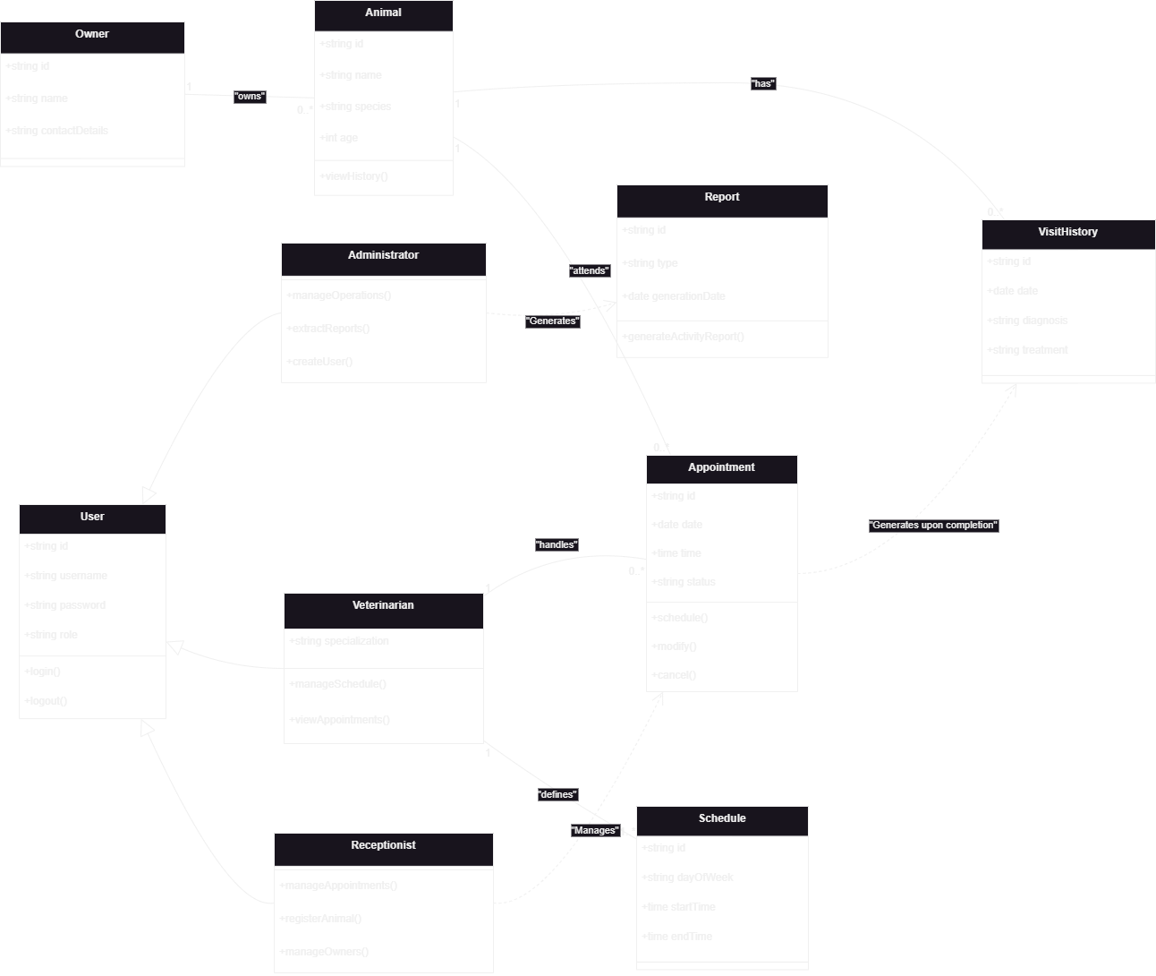

Sequence Diagram

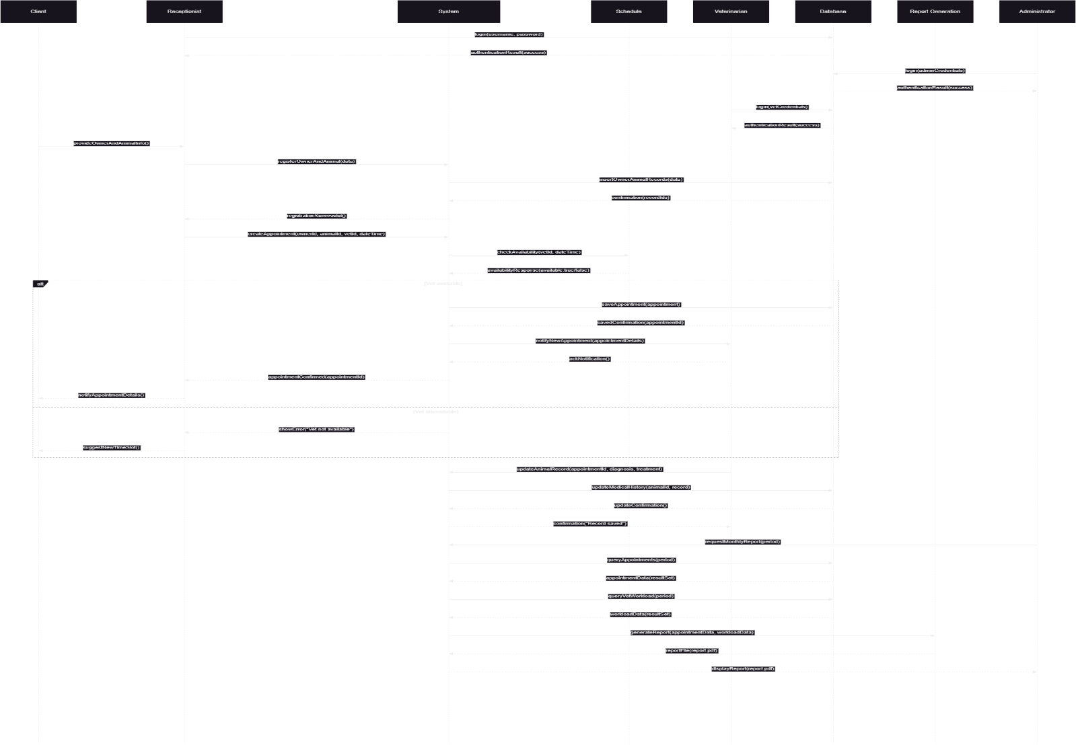

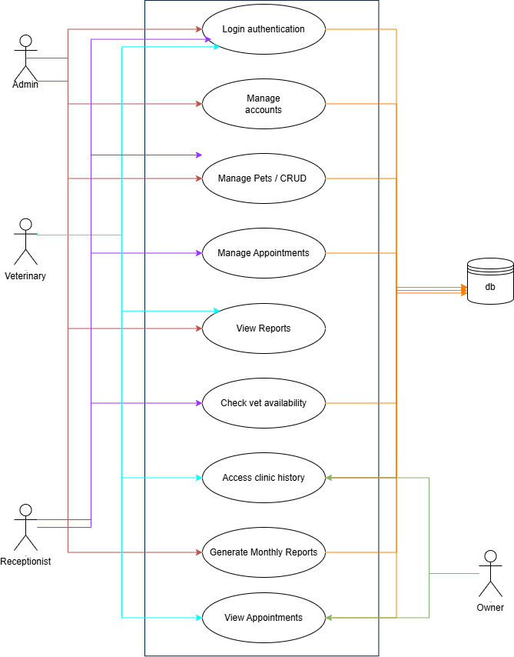
Use Case Diagram

Activity Diagram
